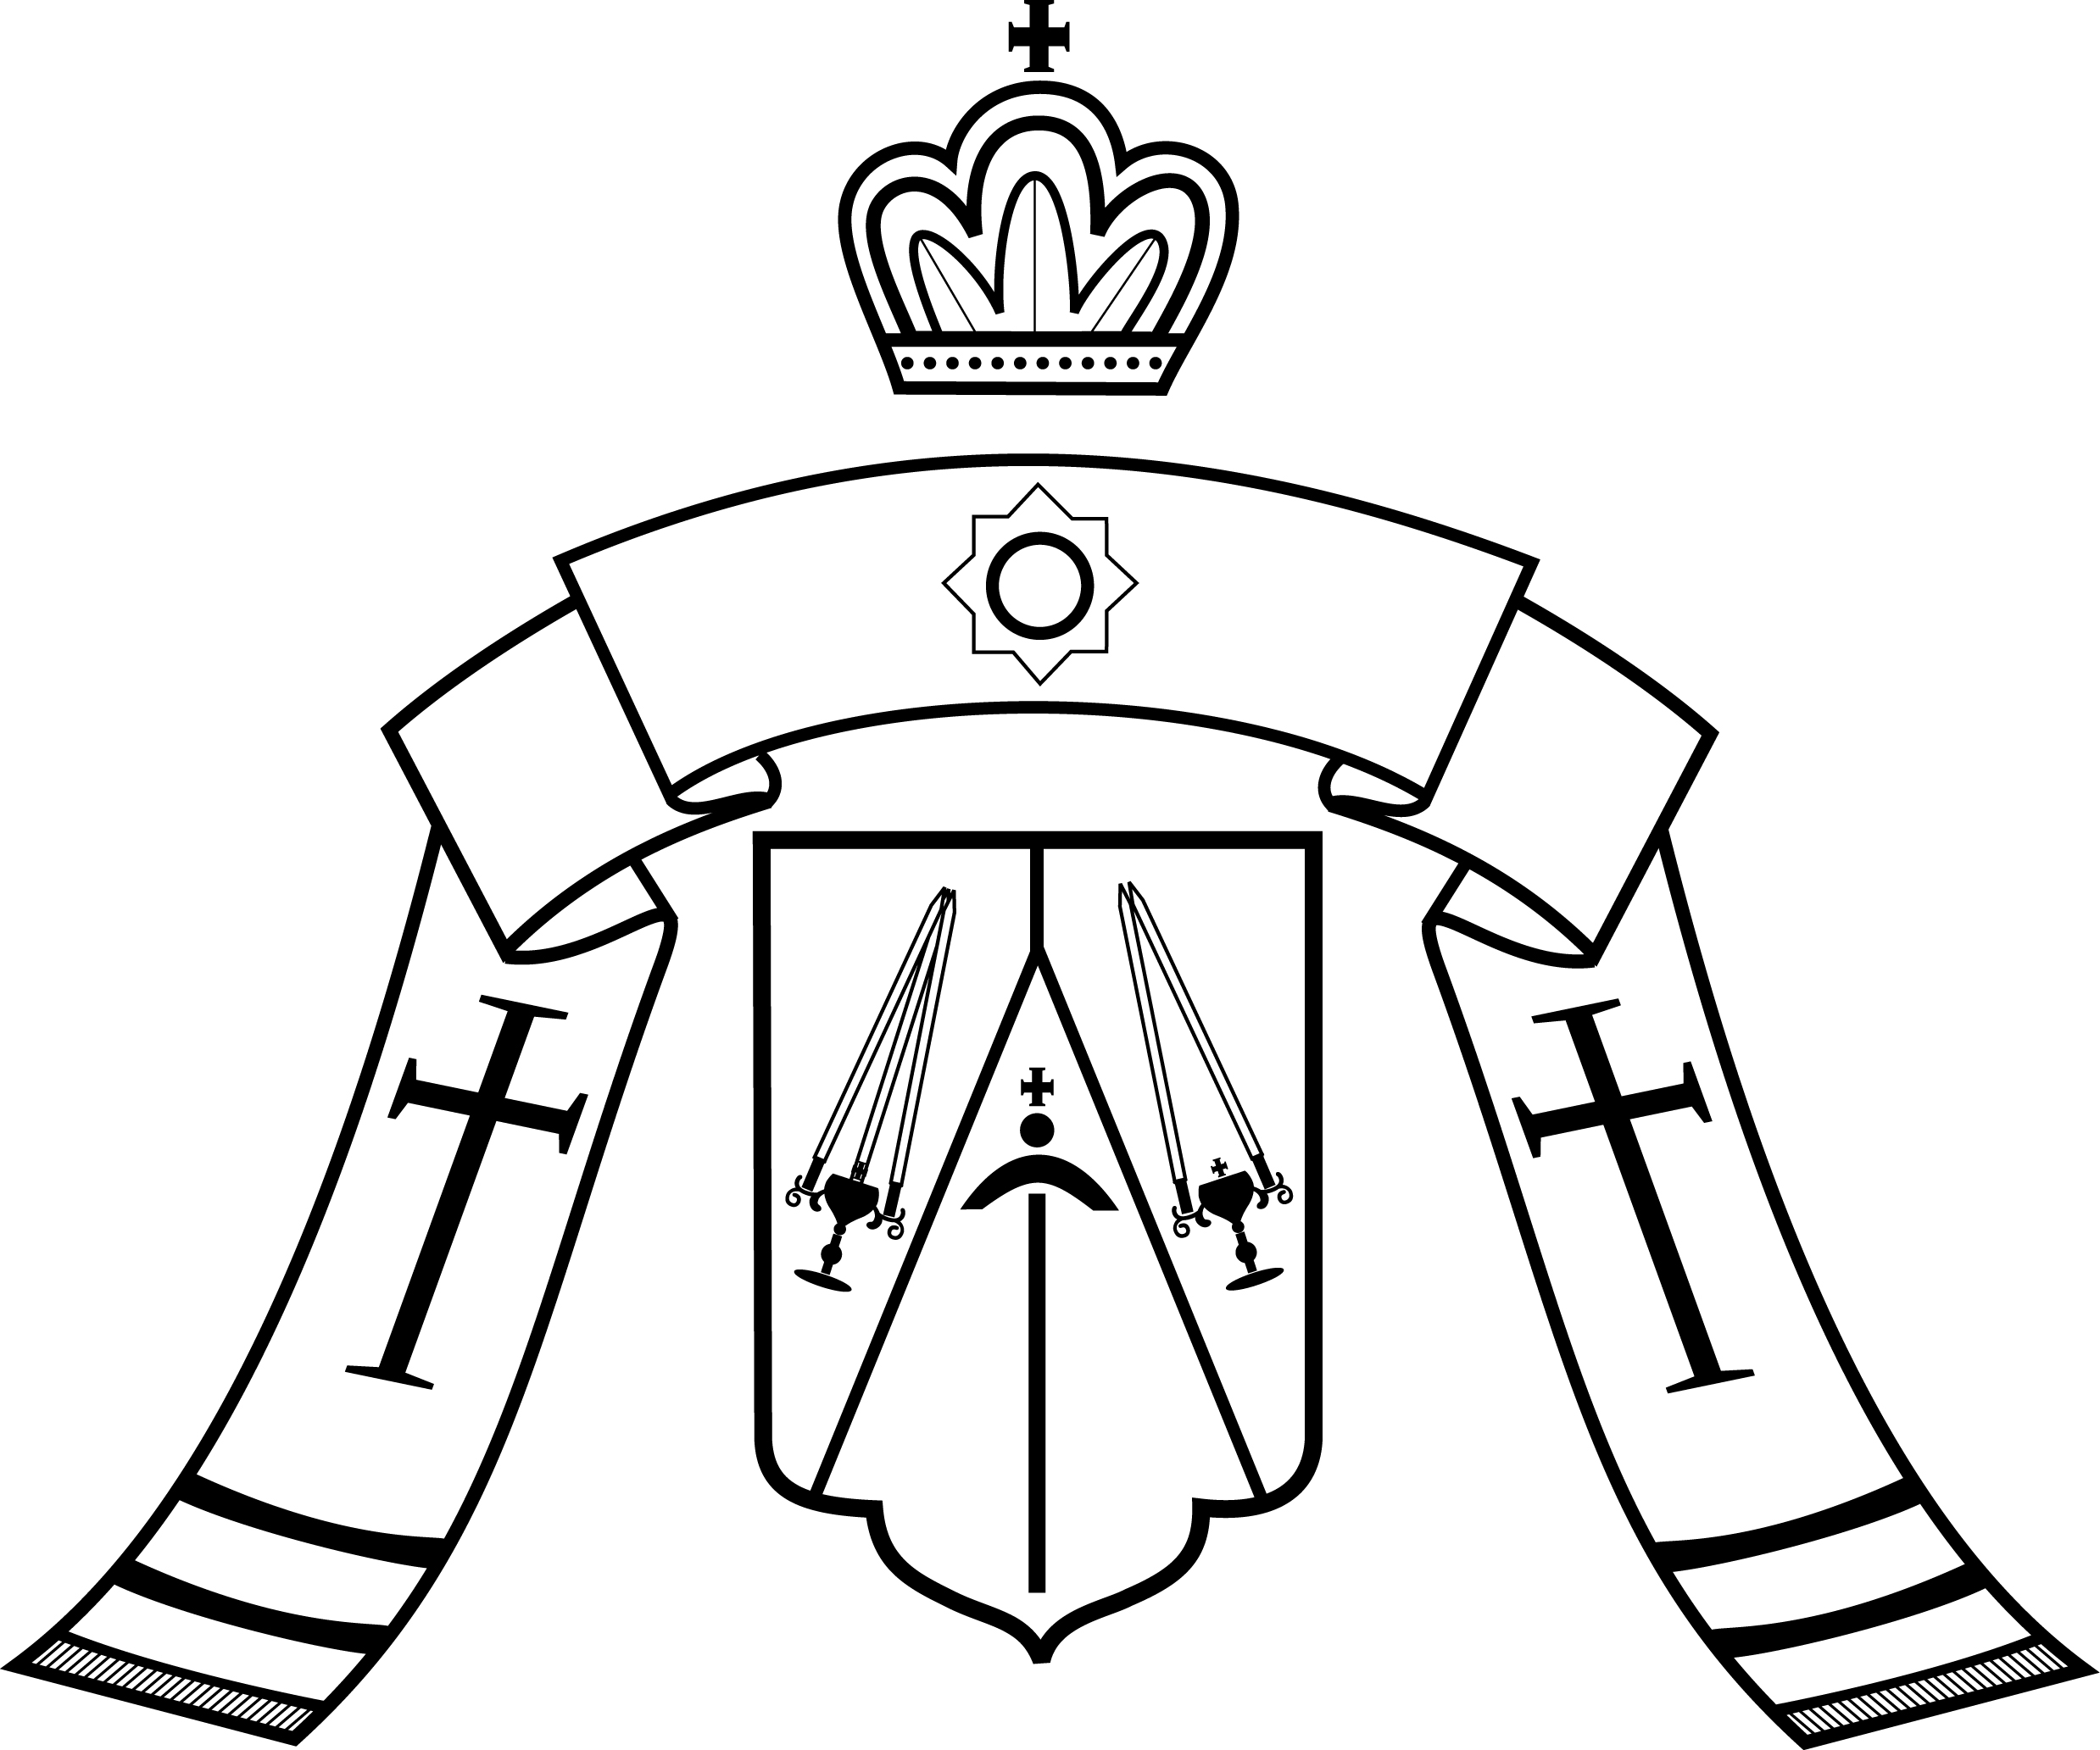

Reverend Fathers, Venerable Monastics, and Pious Faithful of the Western American Diocese:

***Christ is born! Glorify Him!***

We rejoice anew with the triumphant Feast of our Saviour’s coming in the flesh. Today the Lord who arrayed the heavens and the earth stoops down to the meekness of our frail lives, and in His compassion unites our tender flesh to the unconquerable power of His divinity. He is come as a babe, that babes might grow into the fullness of His glory; and there is no response which we in our spiritual infirmity can give, in the face of this act of divine love, than to heed with wonder the words of the angel: ‘Rejoice!’ Thus we do rejoice indeed, with all our hearts, that the God of Creation has seen fit to united creation to Himself, and to raise us up into the glory of His love!

May we, each of us, call to mind in this season the words of that divinely-wise pastor and shepherd, so dear to our hearts in the Russian Diaspora, St John of Kronstadt, which once he proclaimed in the Church on this radiant Feast:

*Behold, God appeared in the flesh: rejoice and be exceeding glad, O earth! Rejoice and celebrate, ye earth-born! The Creator Himself did come to you, in order to create you anew; to restore you, who were corrupted by transgressions! To you did He come: the almighty Physician Himself!*

I have no greater prayer for the flock this Lord has entrusted to my care, than that each of you may ‘rejoice and be exceeding glad’ in the way described by the Righteous St John. The Saviour of the world has come, not just to the world as a whole, but to you, to me, to each of us. The Physician Who can heal every ill has made Himself present in the very flesh of our suffering, that He may heal all that is weak and wanting within us, and lift us up in purity to join the heavenly choirs that rejoice eternally in His divine presence.

May His Nativity renew in us the awe and humility we feel before so gracious, loving, and merciful a God as He Who is born today. Amen.

Bestowing upon you my archpastoral blessing, and wishing you the joy of the Feast,

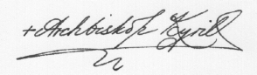Nativity of Our Lord,

25 Dec./Jan. 2016